

BAHRIA UNIVERSITY (KARACHI CAMPUS)

Assignment-01

(Software Construction)

Class: **BSE [4]-5 (B)**

Course Instructor: **Dr. Salahuddin Shaikh**

Date: **(19/10/2023)**

Student’s Name: **Muhammad Shoaib Akhter Qadri**

**(Morning)** Submission Date: **31/10/2023** Max Marks**: 5 M**

Reg. No: **79290**

Title: Software Construction: Transitioning from Design to Implementation

**GROUP MEMBER**

Mutayyab Imran 02-131212-063

Adeeb ul Hassan 02-131212-002

Ahsan Sajjad 02-131212-049

Muhammad Shoaib Akhter Qadri 02-131212-009

**Assignment Objective: In this assignment, students will work on transitioning a software project from the design phase to implementation while also considering software engineering process models and infrastructure for process improvement.**

**Assignment Description:**

**Part 1: Design Review (40%)**

**Select a Project: Choose a software project that you would like to work on. This project can be selected based on the student's preferences or can be assigned by the instructor.**

**Review the Design: Evaluate the existing software design for the selected project. Identify strengths, weaknesses, and areas that need improvement.**

**Propose Design Enhancements: Suggest design enhancements or modifications based ss the software.**

**Selected Project:** **Hospital Management System**

A Hospital Management System (HMS) is a tool that collects data about patients, doctors, staff, hospital administrative details in one software. It's designed to make the whole process paperless. Here are some strengths, weaknesses, and areas for improvement:

**Review the Design:**

**Strengths:**

**1. Data Centralization:** HMS collects data about patients, doctors, staff, and hospital administrative details in one software. This centralization of data can improve efficiency and accessibility.

**2. Automation of Routine Tasks:** HMS helps to automate routine tasks, optimize staff coordination, improve communication, distribute the workload.

**3. Financial and HR Management:** HMS provides financial and HR management, which can help streamline these critical aspects of hospital operations.

**Weaknesses:**

1. **User Interaction:** When new patients come to the appointment, the doctors register them in the system. So that patients don't even interact with the HMS at the beginning. This could be seen as a weakness as it limits patient engagement with the system.

**2. Complexity:** The system can be complex due to the different modules for each role. This could potentially lead to difficulties in training staff to use the system effectively.

**Areas for Improvement:**

**1. Patient Interaction:** Improving the initial interaction of patients with the system could enhance patient experience and engagement.

**2. User-Friendly Interface:** Making the system more user-friendly can help reduce its complexity and improve its usability.

**3. Customization:** The system could be improved by allowing more customization to cater to the specific needs of different hospitals.

**Initial Prototype of System**

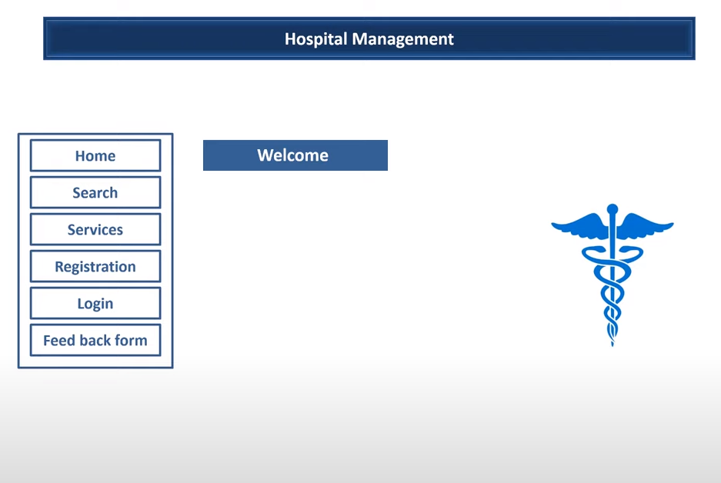

Sidebar Navigation Panel of HMS

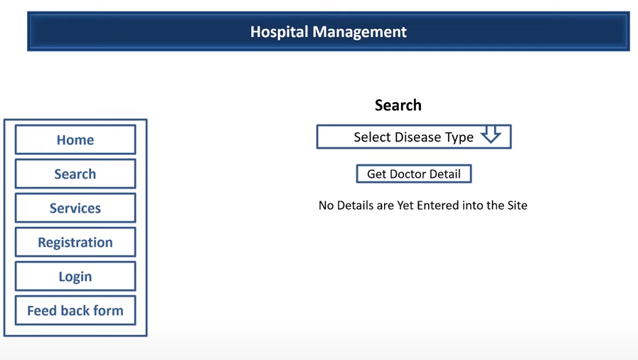

Search of HMS

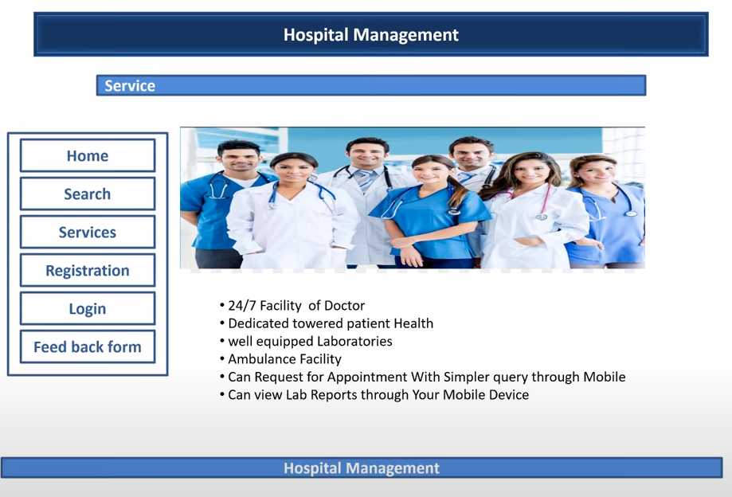

Service Page of HMS

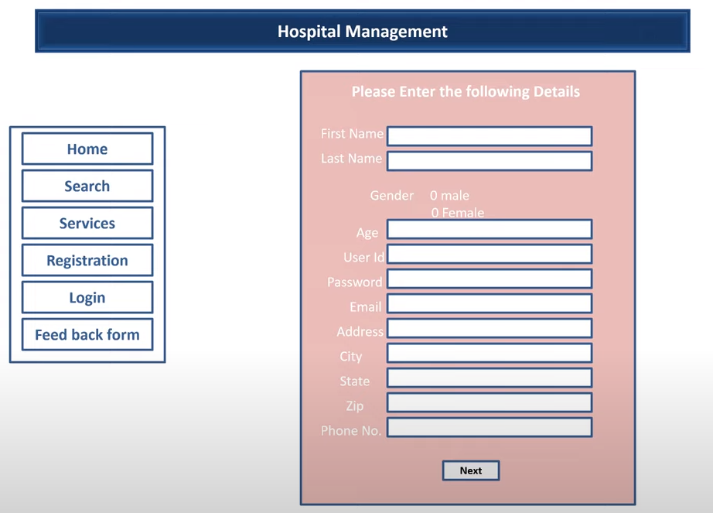

Register Page of HMS

Login Page of HMS

Feedback Page of HMS

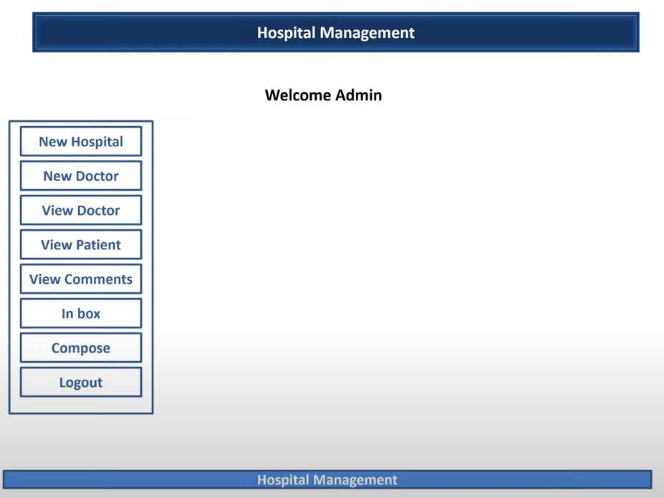

Doctor Signup

Doctor Signup

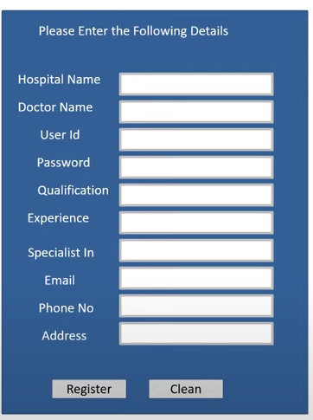

Patient Details

**Receive Message form doctor**

Doctor Signup

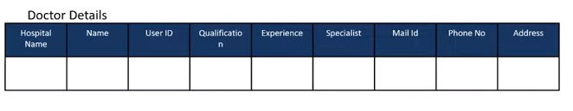

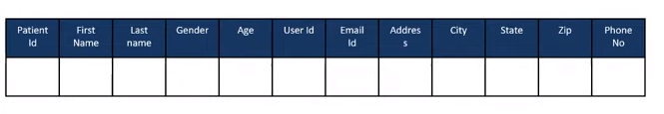

**Patient Details**

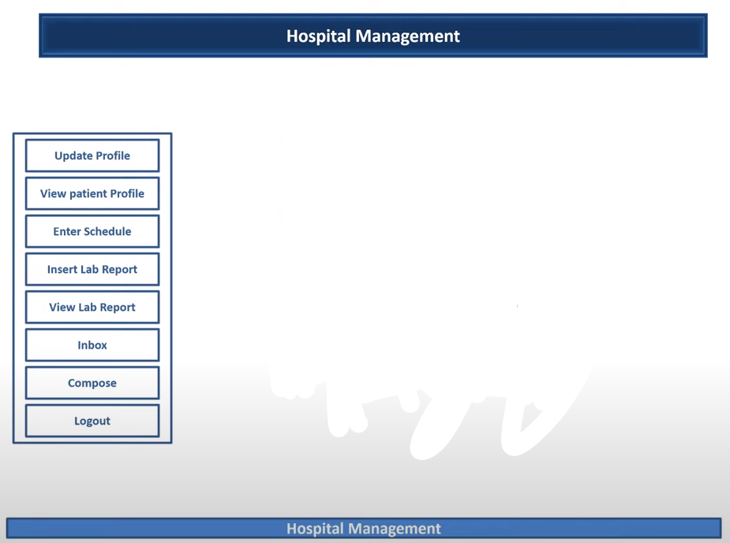

**Update profile of doctor**

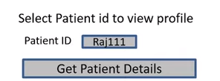

**Appointment for patient**

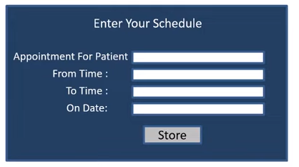

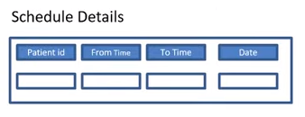

**Schedule Details Format shown.**

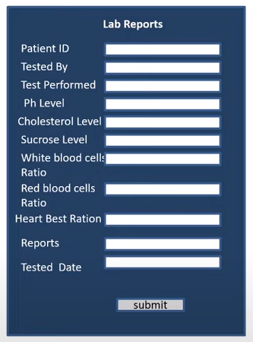

**Propose Design Enhancements:**

Here are some design enhancements for a Hospital Management System (HMS) based on software engineering principles:

1. **User-Centered Design:** The HMS could be redesigned with a focus on user-centered design. This means designing the system with the end-users (doctors, nurses, administrative staff, and patients) in mind. This could involve conducting user research to understand their needs and pain points, and then designing the system to address these. This could improve the overall user experience and usability of the system.
2. **Modular Design:** The HMS could be designed in a more modular way. This means breaking down the system into smaller, independent modules that can function separately. This could make the system easier to understand, maintain, and enhance.
3. **Security Enhancements:** Given the sensitive nature of the data handled by the HMS, security should be a top priority. This could involve implementing advanced encryption methods, secure user authentication, and regular security audits.
4. **Scalability:** The HMS should be designed to be scalable. This means that it should be able to handle an increasing amount of work by adding resources to the system. This could involve using cloud-based solutions or distributed databases.
5. **Interoperability:** The HMS should be designed to be interoperable with other systems. This means that it should be able to exchange and make use of information from other systems (like lab systems, pharmacy systems, etc.). This could improve the efficiency and effectiveness of the hospital’s operations.

These enhancements can improve the overall quality of the software by making it more user-friendly, maintainable, secure, scalable, and efficient.

**Process Model Selection:**

For a Hospital Management System (HMS), the **Agile** software engineering process model would be most suitable. Here’s why:

1. **Iterative Development:** Agile promotes iterative and incremental development where requirements and solutions evolve through collaboration between cross-functional teams. This is beneficial for an HMS as it allows for continuous improvement and adaptation to changes, which are common in a dynamic environment like a hospital.
2. **User Involvement:** Agile involves regular interaction with the end-users (doctors, nurses, administrative staff, and patients), which can lead to a more effective design and better user satisfaction.
3. **Flexibility:** Agile is flexible and allows for changes in requirements during the development process. This is important for an HMS as healthcare regulations, medical procedures, and hospital workflows can change over time.
4. **Frequent Testing:** Agile involves frequent testing throughout the development process, which can help ensure that the HMS is reliable and meets the required standards.
5. **Risk Management:** Agile helps in mitigating risks by breaking down the project into manageable units or sprints. This allows teams to identify and address issues early on in the process.

While Agile seems to be a good fit, the choice of a software engineering process model can depend on various factors such as team size, complexity of the project, organizational culture, etc. Therefore, it’s important to consider these factors before making a decision.